For this assignment we were told to use Octave or Matlab to Plot, Smooth, and Salt a graph in Octave, to show that some applications are better at some things than others. The tutorial that I used to start learning Octave was: <https://en.wikibooks.org/wiki/Octave_Programming_Tutorial/Getting_started>

The first thing this tutorial has you do is plot a function and graph it in octave. When reading the tutorial it seems very easy to plot a graph in a few lines of code. The first graph that I did was sin(x). Here is the graph that octave printed: 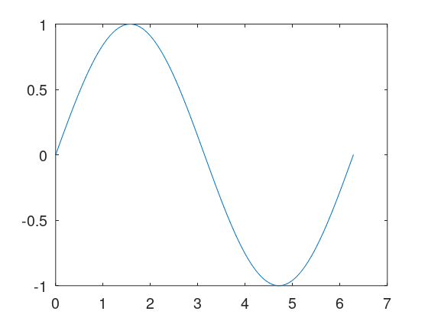

This was very easy to do as it was just 4 lines of code, and one of those lines being to plot the function. The next graph that the tutorial had me graph was a = cos(2\*x), b = sin(4\*x), and c = 2\*sin(x). Then from there I plotted the individual functions then added them together to create this graph, the function is: (x, a+b+c): 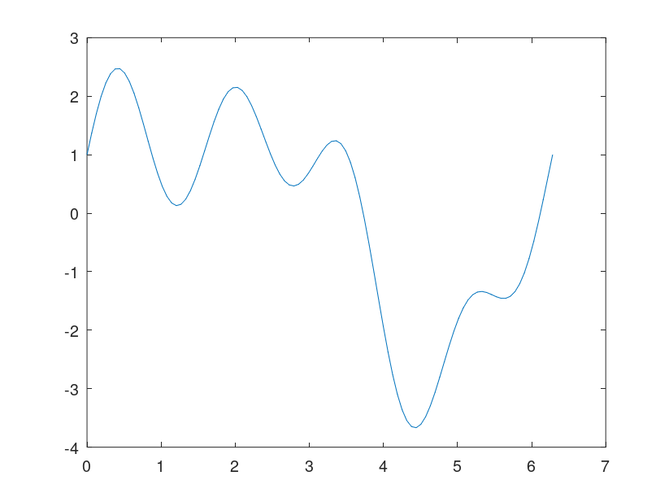

When I was doing this report I was not sure if we were supposed to do tutorials for both applications so I went ahead and did a basic tutorial for Matlab as well. The tutorial that I used for Matlab was: <https://www.mathworks.com/help/matlab/getting-started-with-matlab.html> The first thing that they tell you to do in the Matlab tutorial is to assign values to variables. The next thing the tutorial had me do was to create an array, this method of creating an array was different to the technique that I am used to. From there it went on to plotting lines and functions. The function I plotted in Matlab was sin(x) and the graph that was produced was: 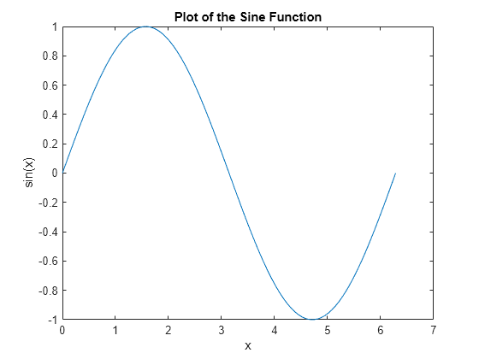

It also talked about naming the graphs and the x and y axis which is something that was not included in the octave tutorial.

From the tutorials I went on to use matlab for this assignment because it seemed easier to use. In using Matlab it was very easy to plot salt and smooth a function. For the plot function it was very simple, it was just setting y1 = to sin(x1), salting the graph was a little bit more difficult if it was not just setting a variable. For salting I used the rand function to make the graph salted, and for smoothing I used the movmean function to smooth the graph. Which movmean calculates the mean over a set, therefore smoothing out the data.

